**Structure of the U.S. Banking System**

The U.S. banking system is a complex network of institutions and regulatory bodies designed to ensure financial stability, facilitate economic growth, and provide various financial services to individuals and businesses. Here’s a breakdown of its structure:

1. **Federal Reserve System (The Fed)**

Board of Governors

Located in Washington, D.C., the Board of Governors consists of seven members appointed by the President and confirmed by the Senate.

The Board oversees the Federal Reserve Banks, regulates certain aspects of the banking system, and sets key policies.

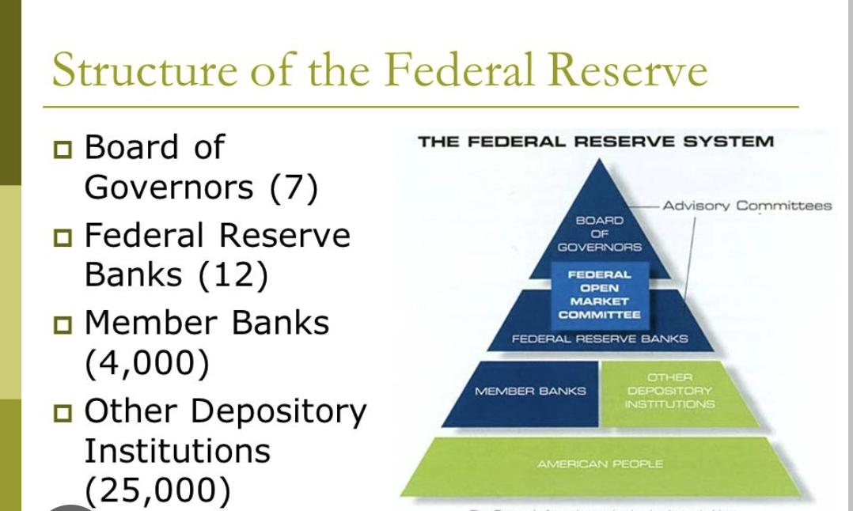Federal Reserve Banks

**Video links**: https://youtu.be/hs_OjESutGk?si=2Q7elYRSDQUm3eMK

There are 12 regional Federal Reserve Banks located in major cities across the United States.

These banks serve as the operating arms of the Federal Reserve System and provide various services to commercial banks, the U.S. government, and the public.

Each Federal Reserve Bank operates within its own district.

Federal Open Market Committee (FOMC)

The FOMC is responsible for setting monetary policy, particularly through open market operations.

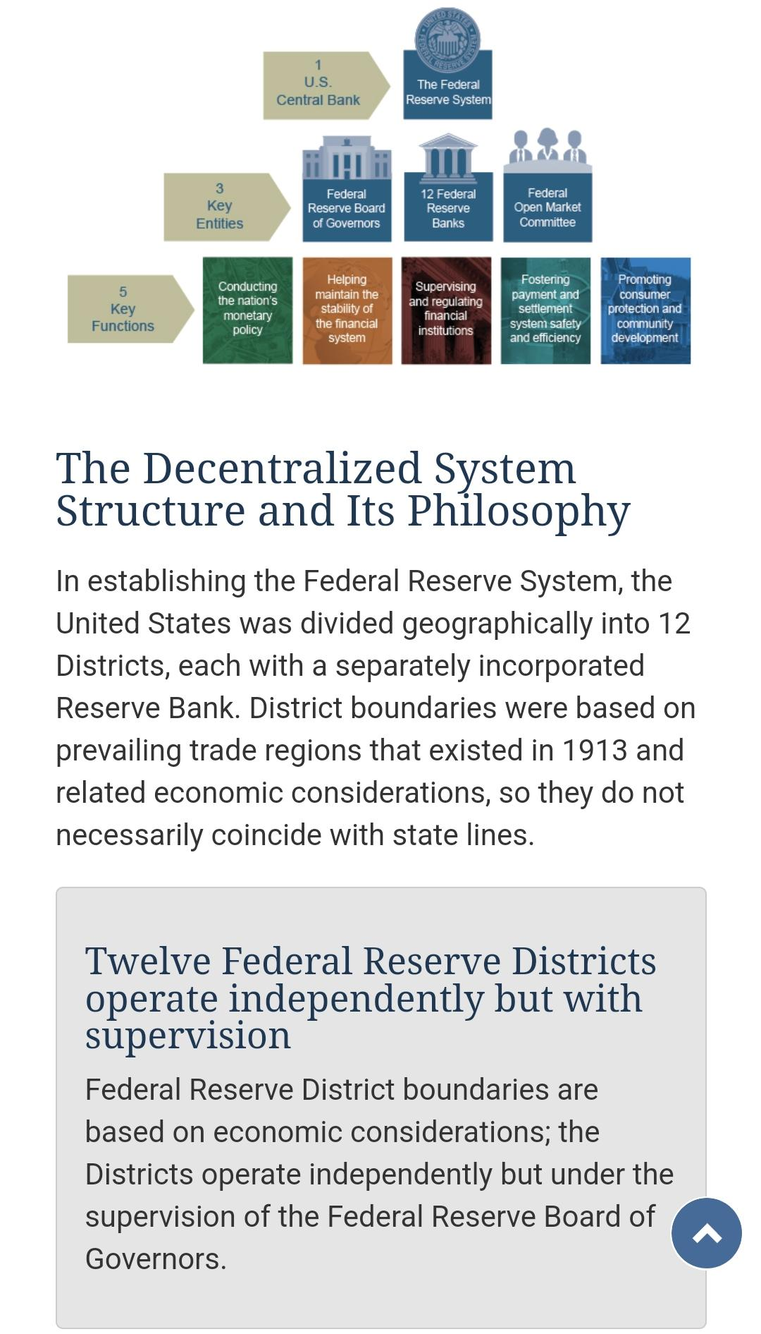It consists of the seven members of the Board of Governors and five of the twelve regional Federal Reserve Bank presidents.

**Video link** https://youtu.be/lJTmCv2kKKs?si=2qKG23wMqXRh1YAe

1. **Commercial Banks**

National Banks

These banks are chartered by the Office of the Comptroller of the Currency (OCC) and must be members of the Federal Reserve System.

They are subject to federal regulations and oversight.

State Banks

These banks are chartered by state banking authorities and can choose to be members of the Federal Reserve System.

They are regulated by state authorities as well as the Federal Reserve (if they are members) or the FDIC (if they are non-members).

Community Banks

Smaller banks that focus on providing services to local communities.

They are typically state-chartered and emphasize personal relationships with their customers.

1. **Credit Unions**

Credit unions are member-owned financial cooperatives that provide a variety of banking services.

They are chartered and regulated by either state authorities or the National Credit Union Administration (NCUA).

Credit unions often offer more favorable terms on loans and savings accounts compared to traditional banks.

1. **Savings and Loan Associations (Thrifts)**

Thrifts primarily focus on accepting savings deposits and making mortgage loans.

They are regulated by the Office of the Comptroller of the Currency (OCC) and insured by the FDIC.

Thrifts play a crucial role in residential mortgage lending.

1. **Investment Banks**

Investment banks specialize in complex financial transactions such as underwriting, facilitating mergers and acquisitions, and providing advisory services.

They do not typically accept deposits from the public.

Investment banks are regulated by the Securities and Exchange Commission (SEC) and other regulatory bodies.

1. **Regulatory Bodies**

Office of the Comptroller of the Currency (OCC)

Charters, regulates, and supervises all national banks and federal savings associations.

Federal Deposit Insurance Corporation (FDIC)

Insures deposits at banks and thrifts up to the legal limit.

Regulates and supervises state-chartered banks that are not members of the Federal Reserve System.

Consumer Financial Protection Bureau (CFPB)

Ensures that consumers are treated fairly by banks, lenders, and other financial institutions.

Enforces consumer protection laws and regulations.

Securities and Exchange Commission (SEC)

Regulates and oversees the securities industry, including stock and options exchanges, investment advisors, and mutual funds.

National Credit Union Administration (NCUA)

Regulates and supervises federal credit unions.

Insures deposits at federal credit unions and many state-chartered credit unions.

1. **Other Financial Institutions**

Non-Bank Financial Institutions

Include mortgage companies, finance companies, insurance companies, and brokerage firms.

These institutions provide various financial services but do not offer traditional banking services like accepting deposits.

Community Development Financial Institutions (CDFIs)

Provide financial services to underserved markets and populations.

Include community development banks, credit unions, loan funds, and venture capital funds.

**Functions of the U.S. Banking System**

1. **Accepting Deposits**

Banks provide a safe place for individuals and businesses to store their money. They offer various types of accounts, such as checking, savings, and certificates of deposit (CDs).

1. **Providing Loans**

Banks lend money to individuals and businesses for various purposes, including personal loans, auto loans, mortgages, and business loans. This lending is critical for economic growth as it provides the capital needed for personal and business investments.

1. **Facilitating Payments**

Banks facilitate a wide range of payment services including check processing, electronic funds transfers (EFT), wire transfers, and credit/debit card transactions. This function is vital for the smooth operation of the economy.

1. **Risk Management and Financial Advisory**

Banks offer risk management services such as insurance and derivatives to help individuals and businesses manage financial risks. They also provide advisory services for investments, retirement planning, and wealth management.

1. **Monetary Policy Implementation**

The Federal Reserve uses tools such as open market operations, discount rates, and reserve requirements to implement monetary policy. These tools influence the supply of money and credit to promote economic growth, full employment, and stable prices.

1. **Safeguarding Financial Stability**

The Federal Reserve and other regulatory bodies oversee the banking system to ensure its stability and soundness. This includes regular supervision and regulation to prevent bank failures and protect depositors.

1. **Providing Financial Services to the Government**

Banks, especially the Federal Reserve, provide various financial services to the U.S. government, including managing the Treasury’s payments, issuing government securities, and handling currency and coin operations.

1. **Promoting Consumer Protection**

Banks are required to comply with various consumer protection laws and regulations designed to ensure fair treatment of customers, prevent discrimination, and provide transparency in financial transactions.

**How Banks Are Helpful for Customers**

1. **Providing Safe Storage for Money**
2. **Facilitating Payments and Transactions** Electronic Funds Transfer (EFT)

Direct Deposits

Bill Payments

Mobile Banking

1. **Providing Credit and Loans**
2. **Offering Financial Products and Service**
3. **Providing Financial Advice and Planning**

Retirement Planning

Investment Advice

Wealth Management

Estate Planning

1. **Risk Management Services**

Life Insurance

Property and Casualty Insurance

Health Insurance

1. **Enhancing Financial Inclusion**
2. **Promoting Economic Stability and Growth**

**How U.S. Banks Generate Revenue**

1. Interest Income
2. Fee Income
3. Trading and Investment Income
4. Interchange Fees
5. Wealth Management and Advisory Services

**References**

**Websites**

[**https://www.investopedia.com/ask/answers/042815/whats-difference-between-prime-rate-and-discount-rate.asp**](https://www.investopedia.com/ask/answers/042815/whats-difference-between-prime-rate-and-discount-rate.asp)

[**https://www.internationalstudentloan.com/resources/understanding-us-banking-system.php**](https://www.internationalstudentloan.com/resources/understanding-us-banking-system.php)

**Video links**

**Video on US Banking**

[**https://youtu.be/MsPgw4FodgE?si=hn6KMZgZIJUe2evN**](https://youtu.be/MsPgw4FodgE?si=hn6KMZgZIJUe2evN)

**Video on Indian Banking**

[**https://youtu.be/QtQic_fegOs?si=BjPzFNxroD9QXJCG**](https://youtu.be/QtQic_fegOs?si=BjPzFNxroD9QXJCG)